Monkeypox Detection using Modified VGG16 & Custom CNN Model

In this project we are designing Transfer Learning Modified VGG16 and Custom CNN algorithm to predict Monkeypox disease as this disease is not deadly but spreading very fastly. To deal with this disease for timely detection doctors can use this algorithms for detection.

To train both algorithms we have used Normal SKIN and Monkeypox images and in both algorithm VGG 16 giving 98% accuracy and Custom CNN giving 99% accuracy.

Below screen showing images used in this project

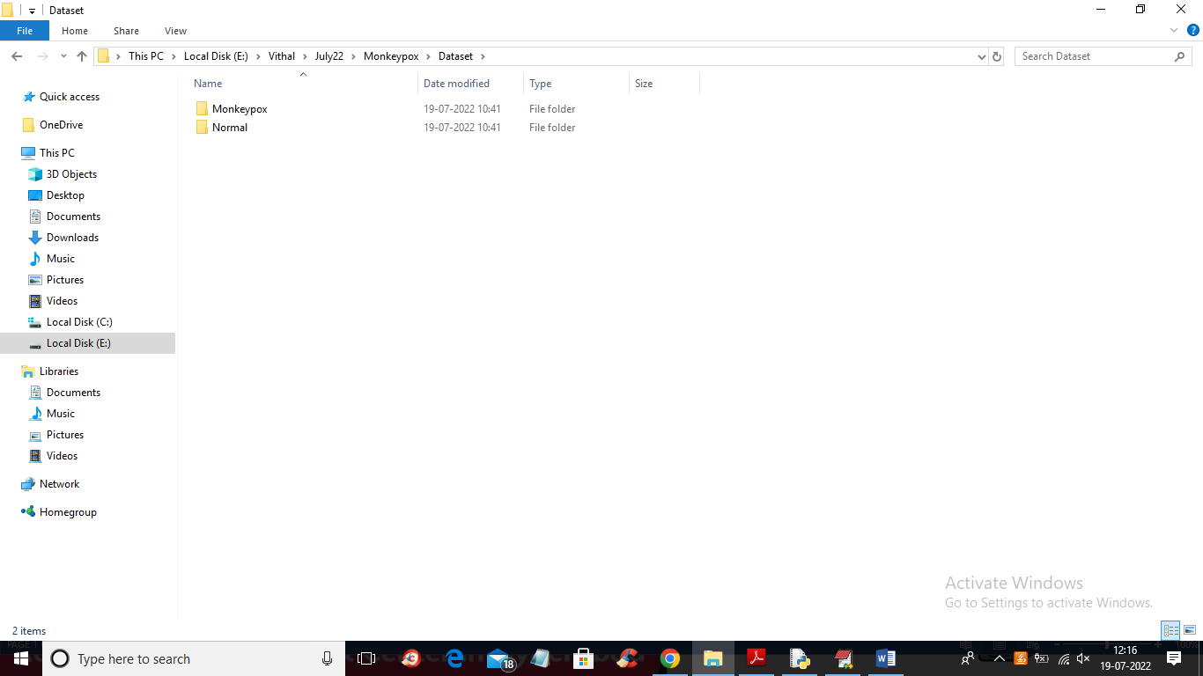

In above screen we have two folders and just go inside any folder to view those images

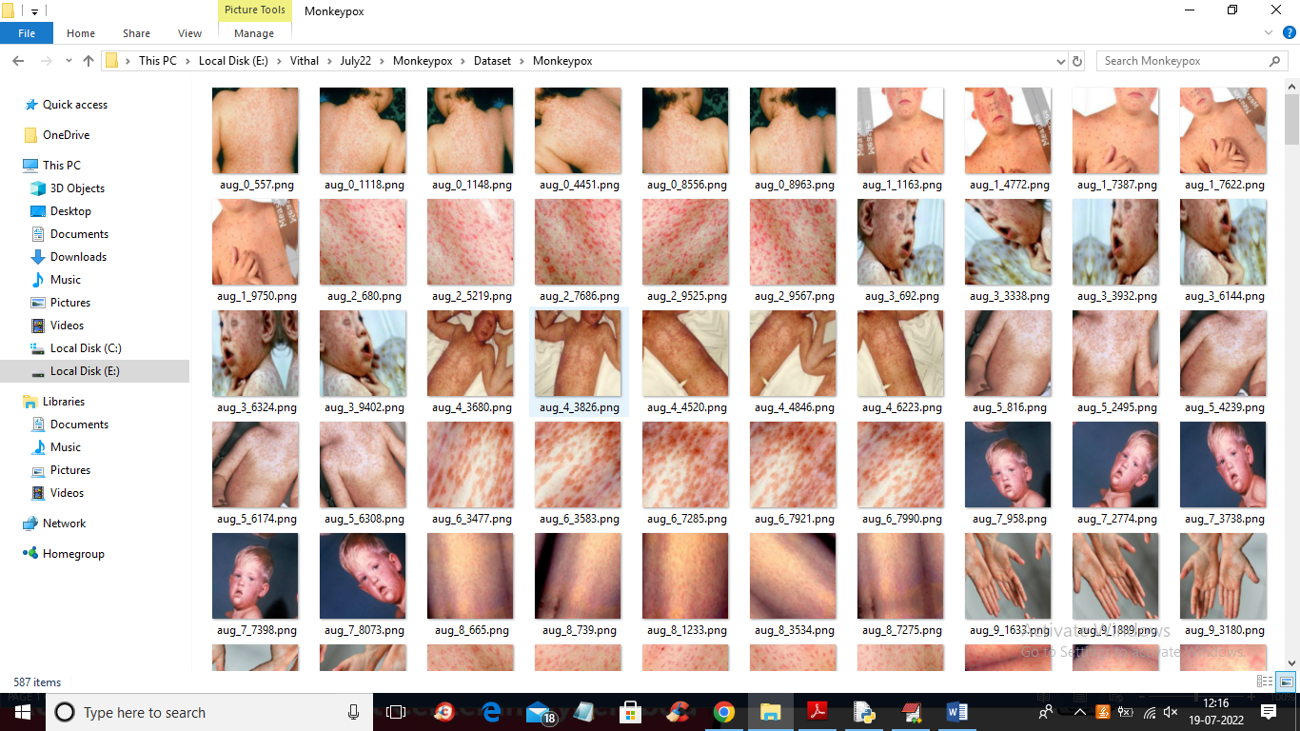

So we are using above images to train VGG 16 and Custom CNN algorithms.

To implement this project we have designed following modules

1. Upload Monkeypox Dataset: using this module we will upload dataset to application
2. Preprocess Dataset: using this module we will read all images and then resize images to equal size and then normalize image pixel values and then split entire dataset into TRAIN and TEST where application user 80% images for training and 20% for testing. 20% test images will be applied on trained model to calculate correct prediction accuracy.
3. Run VGG16 Algorithm: above processed 80% images will be input to VGG algorithm to trained prediction model and this model will be applied don test images to calculate prediction accuracy.
4. Run Custom CNN Algorithm: above processed 80% images will be input to Custom CNN algorithm to trained prediction model and this model will be applied don test images to calculate prediction accuracy.
5. Comparison Graph: using this module we will plot comparison graph between VGG and Custom CNN algorithms
6. Predict Disease from Test Image: using this module we will upload test image and then Custom CNN will predict weather image is normal or contains Monkeypox disease.

In below screen we are showing code with comments on VGG and Custom CNN algorithms

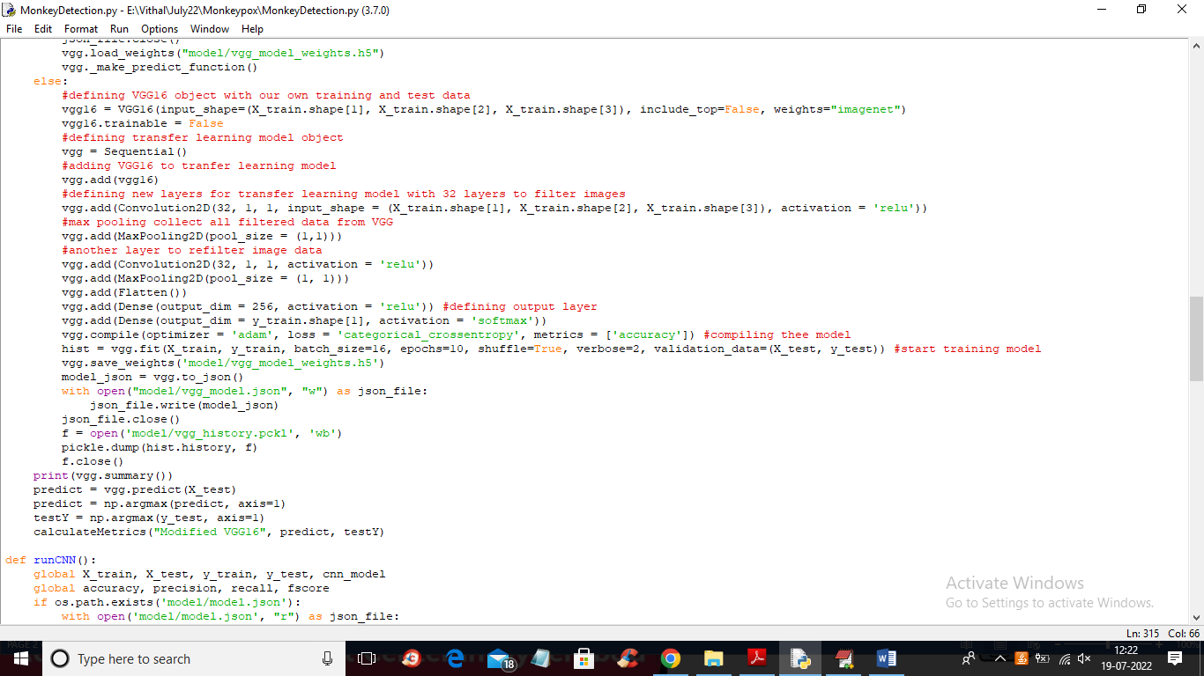

In above screen read red colour comments to know about VGG16 implementation

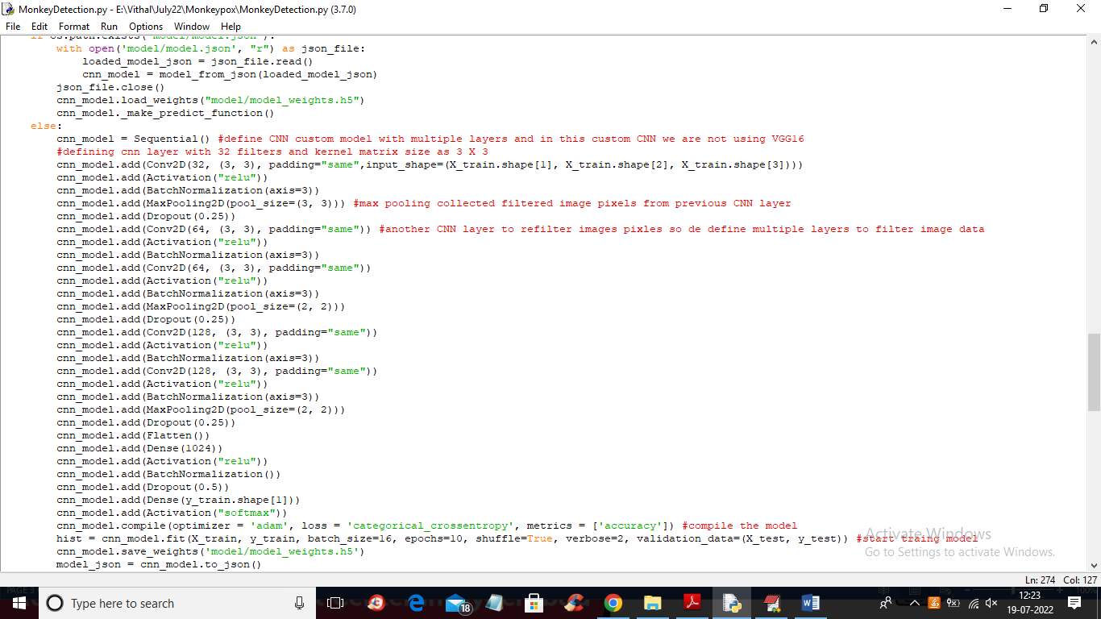

In above screen read red colour comments to know about Custom CNN model

SCREEN SHOTS

To run project double click on ‘run.bat’ file to get below screen

In above screen click on ‘Upload Monkeypox Dataset’ button to upload dataset and get below output

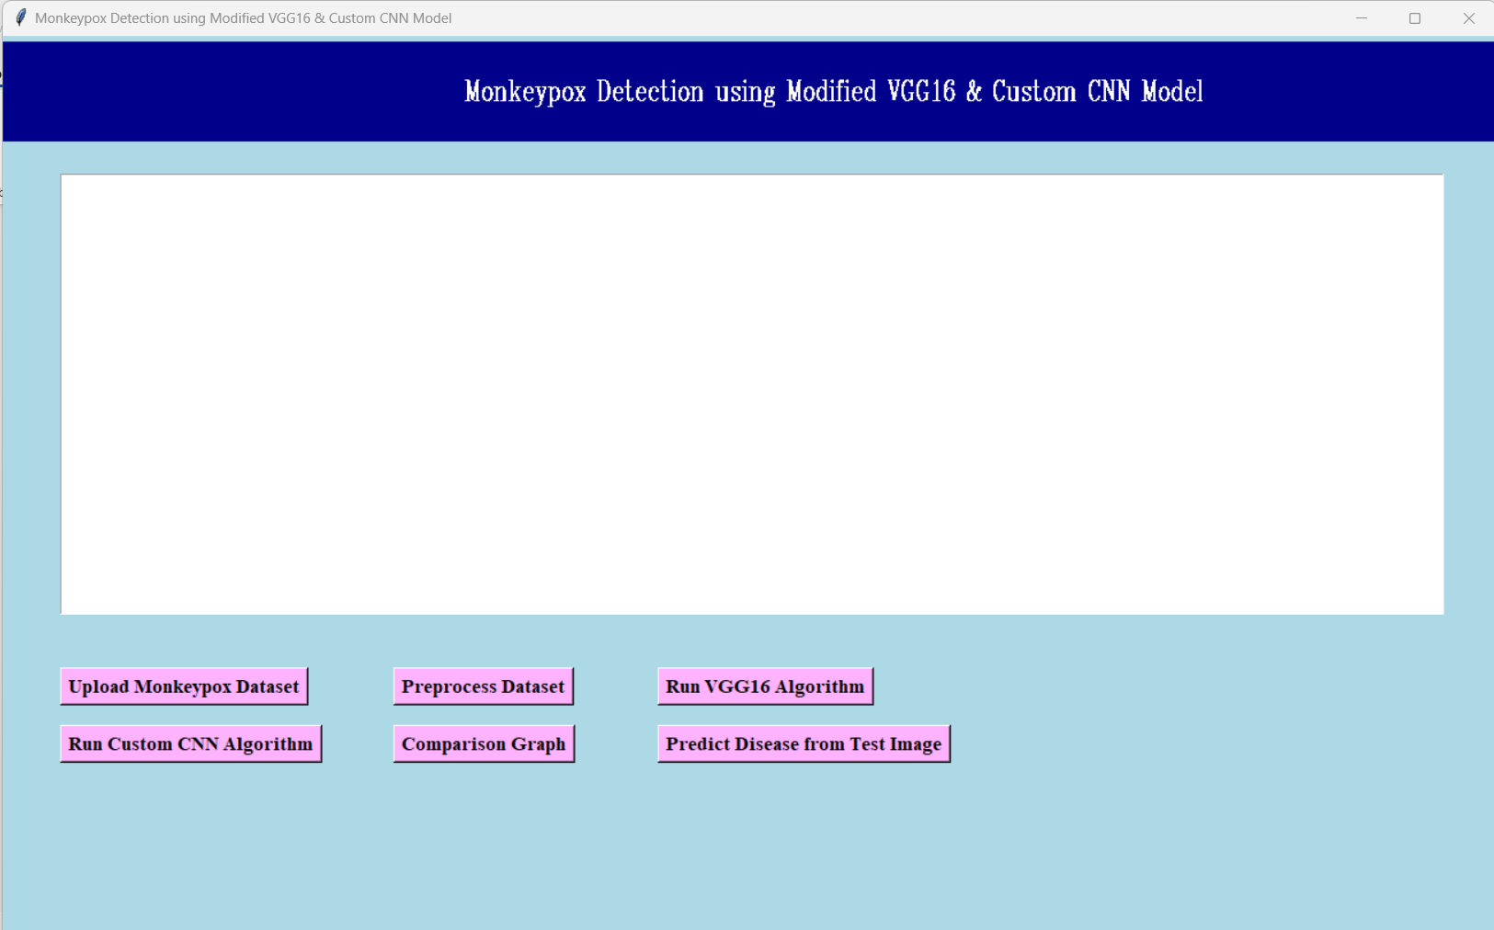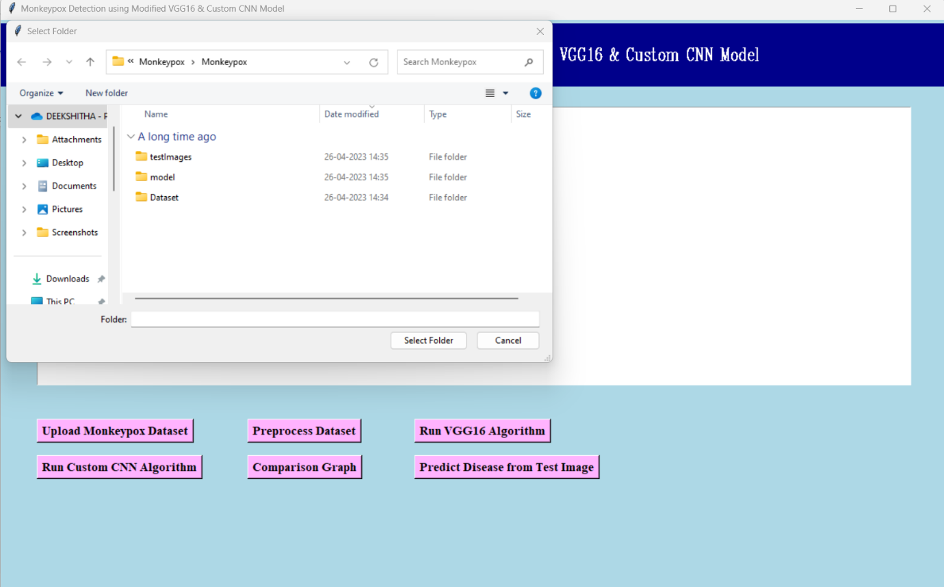

In above screen selecting and uploading ‘Dataset’ folder and then click on ‘Select Folder’ button to load dataset and get below output

In above screen dataset is loaded and now click on ‘Preprocess Dataset’ button to read all images and then processed them

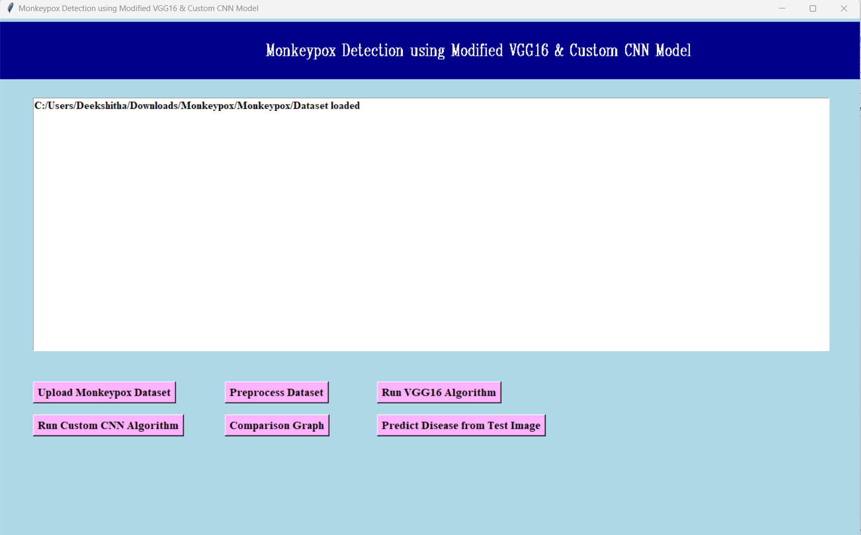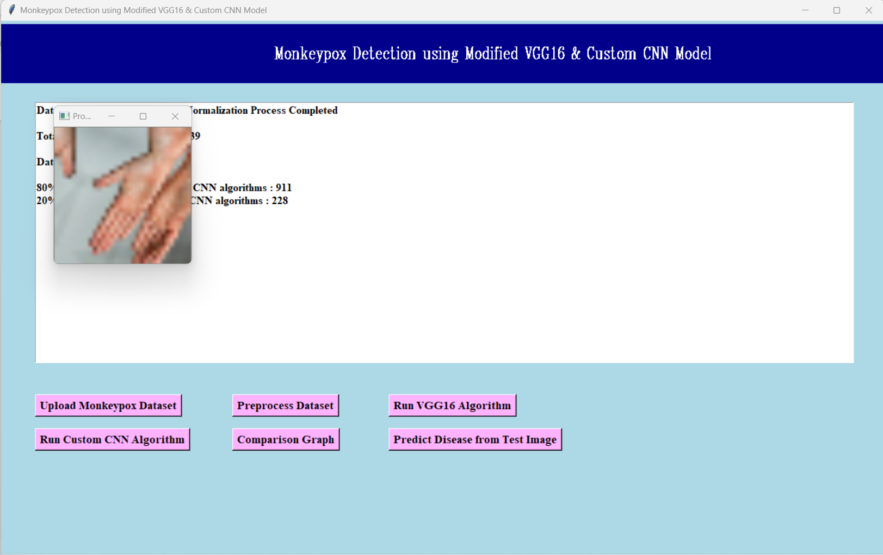

In above screen we can see all images read and then process and we can see dataset contains total 1139 images and application using 911 (80%) images for training and 228 (20%) images for testing and to check all images are processed properly I am displaying one sample image and now close that image and then click on ‘Run VGG16 Algorithm’ button to train VGG and get below output

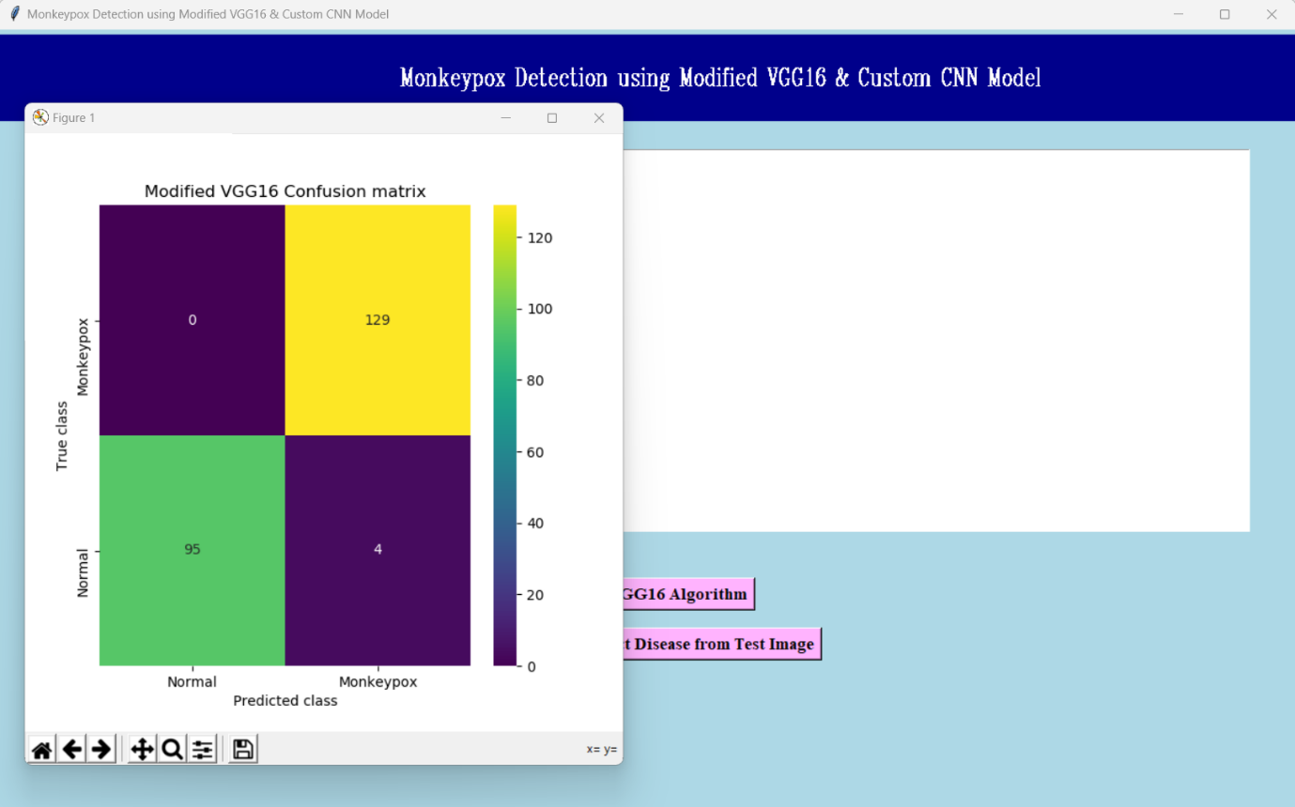

In above screen with VGG16 we got 98.24% accuracy and we can see other metric values also and in confusion matrix graph x-axis represents Predicted Classes and y-axis represents True Classes and we can prediction in matching row and column name is correct and un-matched rows and columns names are incorrect prediction and in above graph we can see VGG16 predicted 1 and 3 (total 4 images) incorrectly and now close above graph and then click on ‘Run Custom CNN Algorithm’ button to train Custom CNN and get below output

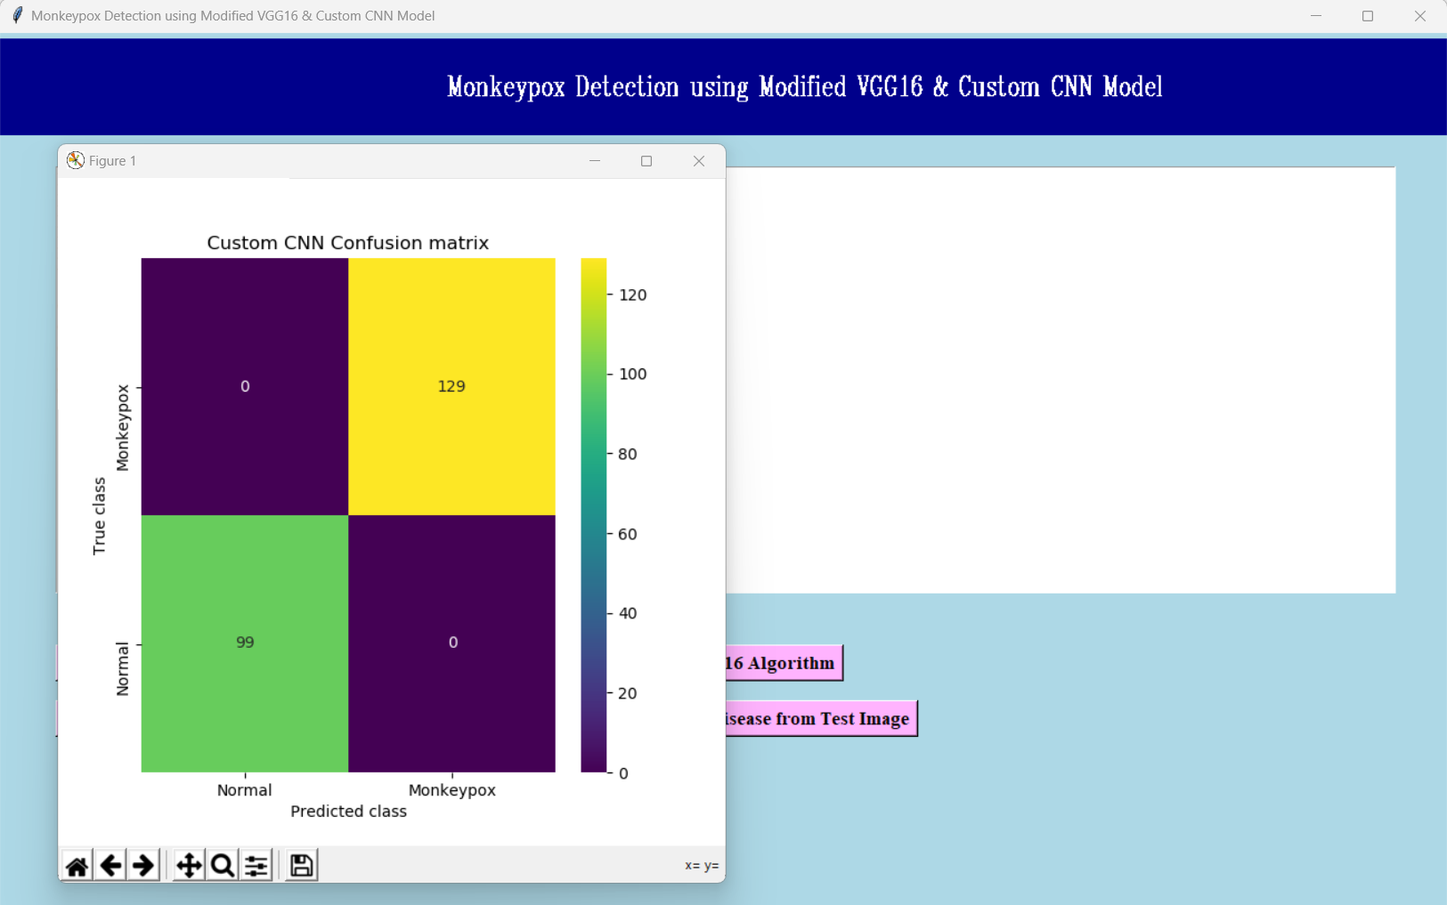

In above screen with Custom CNN we got 99.12% accuracy and in confusion matrix graph we can see only 2 images are incorrectly predicted and now close above graph and then click on ‘Comparison Graph’ button to get below output

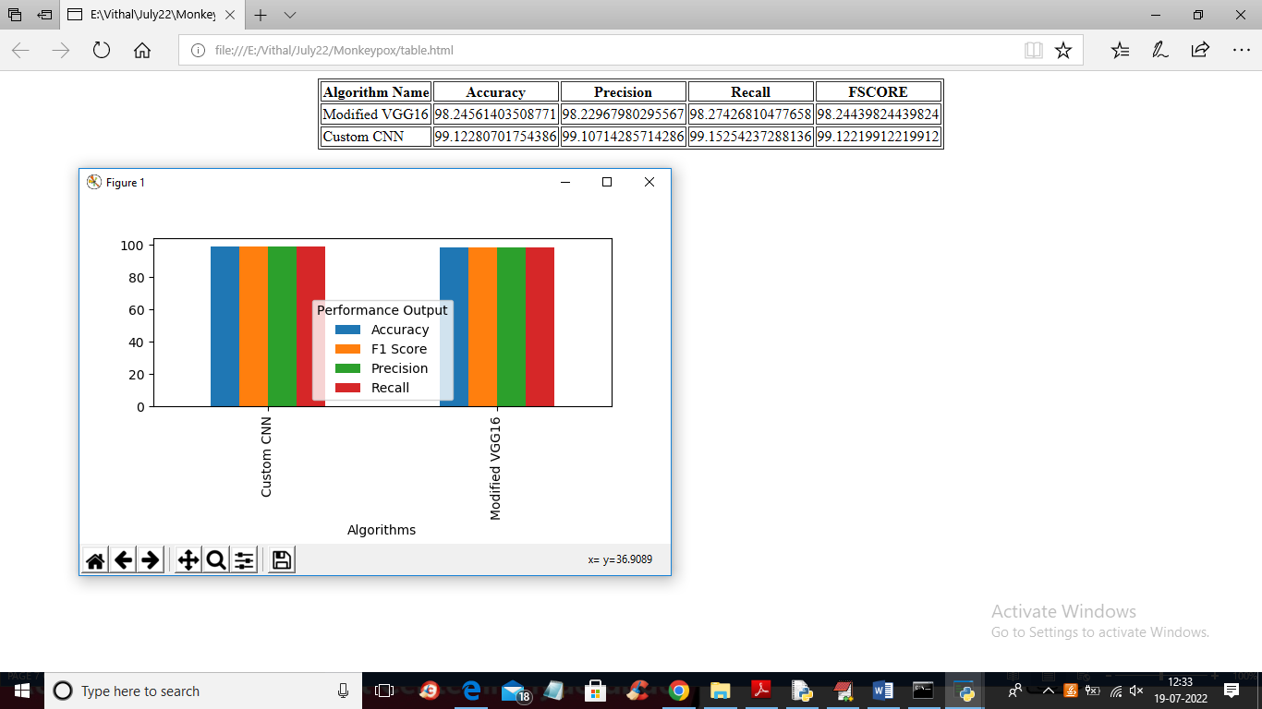

In above screen with tabular format and graph format we can see result of both algorithms and now go back to main application and then click on ‘Predict Disease from Test Image’ button to upload test image and get below output

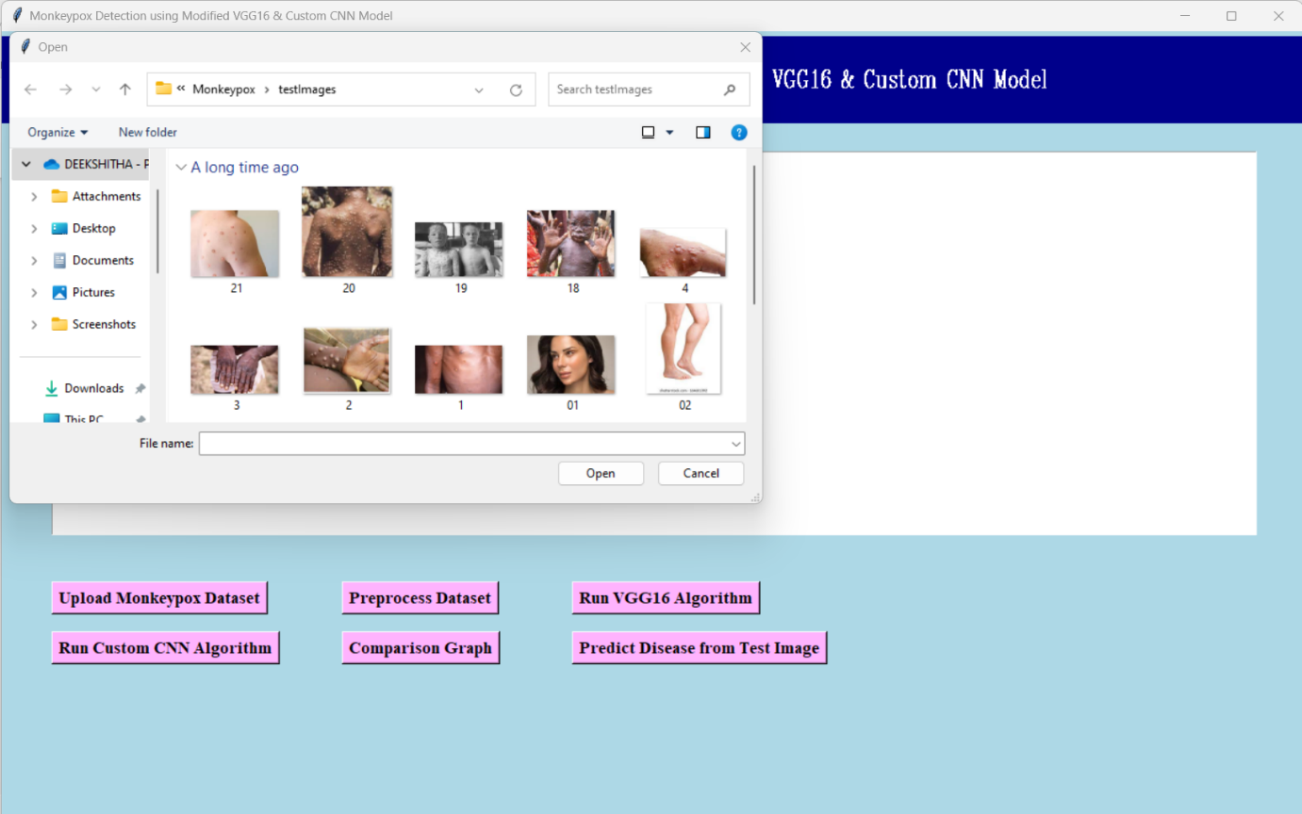

In above screen selecting and uploading ‘4.jpg’ image and then click on ‘Open’ button to get below prediction output

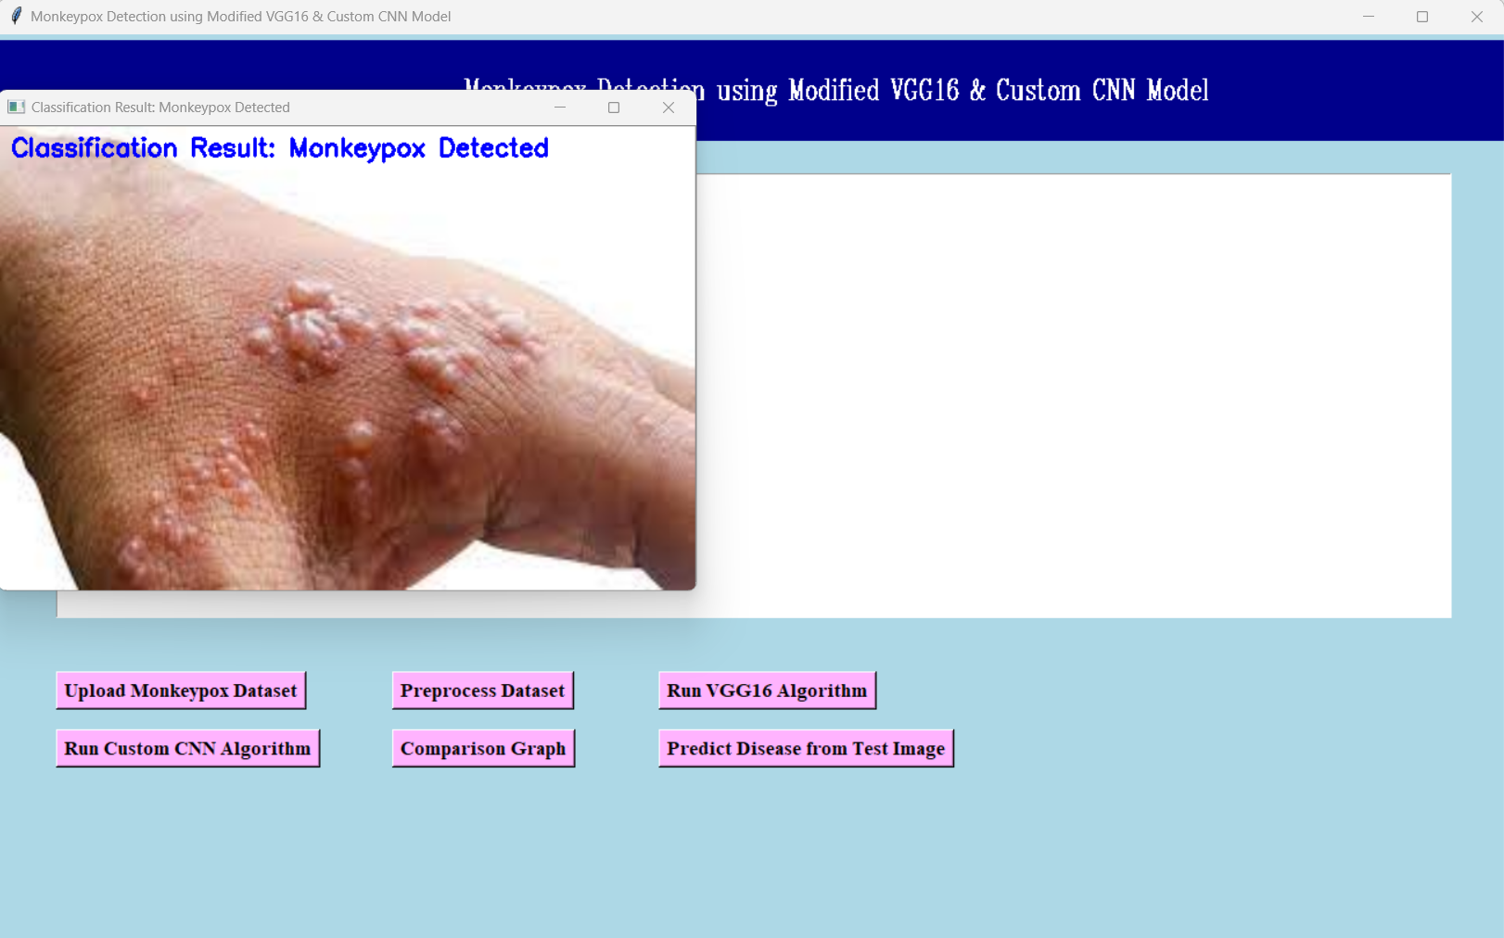

In above screen monkey pox detected and similarly you can upload other images and test them

